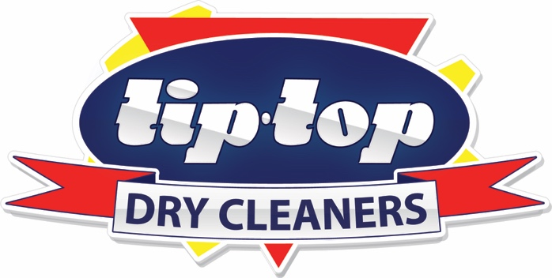

**TipTop Dry Cleaners are proud supporters of the Childhood Cancer Association** and for the month of September, will donate all proceeds from sales of our Haberdashery range, including Lint Rollers, Lint Shavers, Wedding, Suit and Dress Bags etc. to this most worthy cause.